Congress Center of Dicle University,

Diyarbakır, Turkey

www.dicle.edu.tr/eng/Academics/facultyAgr.html

**ANNOUNCEMENT**

**for**

**INTERNATIONAL TRAINING WORKSHOP ON**

**IRRIGATION and FERTILIZATION MANAGEMENT FOR COTTON GROWTH**

**24-28 September 2012**

**In Collaboration With GAP-UTAEM and**

**GAP-BKİ**

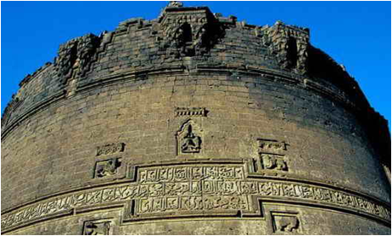

**DİYARBAKIR**

Diyarbakır is one of the largest cities in Southeastern of Turkey and It is situated on the banks of the River Tigris. It is located in an area whose magnificent history, spanning some 5,000 years. Diyarbakır is famed for its culture, folklore, and watermelons. Diyarbakır is surrounded by an almost intact, dramatic set of high walls of black basalt forming a 5.5 km circle around the old city. The Walls were built in antiquity, restored and extended by the Roman emperor Constantius in 349. Diyarbakır boasts numerous medieval mosques and madrassahs including: Great Mosqeu, The four-footed minaret, Hz. Suleyman Mosque, St. Giragos Armenian Church, Archaeological Museum.

Located on a transitional zone between the mountainous Eastern Anatolia and the plains of Upper Mesopotamia, Diyarbakır was once on important trade routes and it is still at the center of the main highway network reaching such centers as Elazig, Sanliurfa, Mardin and Bitlis. Railway reached the center of the province. Diyarbakir also has an airport with flights to all major centers in Turkey.

Diyarbakır has a semi-arid climate. Summers are very hot and very dry. Average temperature is 25 oC in September.

City Walls

**REPUBLIC OF TURKEY**

**DICLE UNIVERSITY**

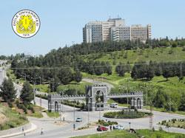

Dicle University

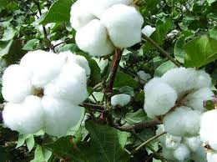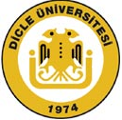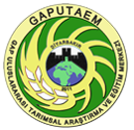

*.*

**THEME and OBJECTIVES OF THE TRAINING WORKSHOP**

Agriculture is still a very important sector of the economy. In 2010 it represented 10.1% of GDP and 24.7% of employment in Turkey. Turkey is one of the top 6 producers of cotton in the world. Cotton lint production was 638 250 tons. Cotton is crucial to the wider economy since it provides the fiber for textiles. It is primarily grown on the coastal plains of the Mediterranean and Aegean seas, in the Southeastern Anatolia. Approximately 50% of cotton production of Turkey is provided from Southeastern Anatolia Region which is in the region held the workshop. Thus, cotton is “white gold” not only for Turkey but for many other countries.

On the other hand, water and fertilizer management are an essential task for all crop production. A cotton plant's water requirements vary by the environment it grows in. The dryer and hotter the environment is, the more water the plant requires. Since water is a limited resource, and due to economic constraints related to costs of water, pumping and labor needed to apply irrigation. Due to the semi-arid climate and high summer temperatures, all the cotton area are irrigated in Turkey and it is one of the most important crops consuming much more irrigation water. The availability of freshwater for agricultural use is declining in many areas of the world. Thus Turkey has got appropriate practical experiences on cotton growth. The present training workshop is organized to disseminate the advance techniques to the professionals working in this field.

The purpose of the workshop is to share the experiences related to irrigation and fertilizing management on cotton growth. The workshop will focus on the following principal themes on cotton:

 Deficit irrigation,

Water-yield response factor (ky),

Use of modern irrigation techniques,

Fertilization/Fertigation,

Response of cotton varieties to water scarcity,

Role of the climate factors on cotton yield,

The methods and devices used on cotton irrigation management

Waste water use for cotton irrigation

**TARGET GROUPS**

Persons from academics, research institutes and environmental groups with focus on irrigation and fertilizing management on cotton growth are encouraged to attend the workshop.

The participants are invited to make a presentation (10 minutes) over a national or regional agricultural applications on cotton.

**DURATION AND VENUE**

The duration of workshop will be 5 days. This includes 4 days training sessions and one-day field visit. The workshop will be conducted at Congress Centre of Dicle University, Diyarbakır, Turkey

**TRAINING MODE and FIELD ACTIVITIES**

Each day training session will include presentations on the specific theme of cotton followed by on-hand training in the application of related scientific tools. The training workshop will be conducted in English.

One-day fields/sites visit will be arranged for the workshop participants to physically look and assess the lands grown cotton and some research stations.

**TRAVEL and BOARDING**

The participants will be responsible for travel expenses.

There are flights to Diyarbakır Airport, from Istanbul, Ankara, Izmir, Antalya operated by Turkish Airlines and some private airlines (Pegasus, Onur Air, SunExpress). The participants can use any airlines via one of the city airports stated above.

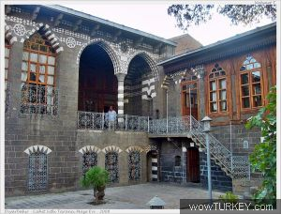

Cahit Sıtkı Tarancı Museum

**SCHOLARSHIPS**

**REGISTRATION AND CORRESPONDENCE**

Dicle University will provide scholarship covering accommodation, catering and course tours for the participants requested a grant and the selected participants. The working/studying candidates on cotton and under 45 years old may apply. The applied candidates will be selected by Organization Committee considering their CV and scope of workshop.

The applicants are invited for participation in the workshop. The application must include a brief curriculum vita of the participant, nationality, country of origin, date of birth, passport number, validity of passport, corresponding address (phone, fax, and email). The maximum 10 persons from Turkey and 20 persons from other countries will be selected. Please make sure that application to participate must reach the organizer not later than 15 March 2012 at the following address:

**Workshop Secretariat**

**Oner CETIN**

Dicle University, Agricultural Faculty, Department of Agricultural Structures and Irrigation

(Ziraat Fakultesi)

21280, DİYARBAKIR/TURKEY

Tel: +90 412 248 85 09

 Fax: +90 412 248 81 53

  Email: oner_cetin@yahoo.com

or onercetin@dicle.edu.tr

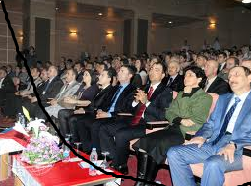

Congress and exhibition center